Github pilot uses
Github copilot is generative AI(example for LLM)

Introduction – AI powered coding assistant
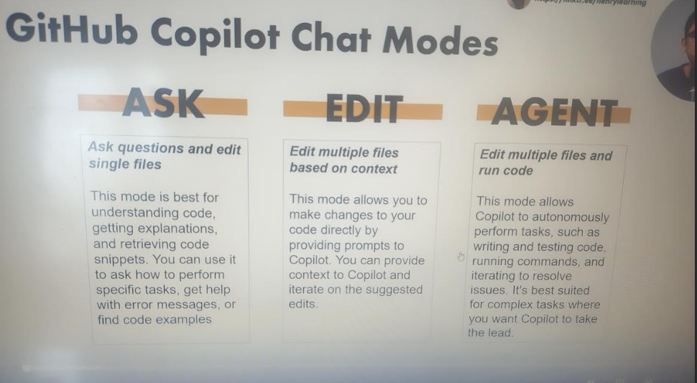

If we want to work with code change /to as questions on project then select – ask mode
If we want to generate code with manual steps then select – ask mode

Suggetions/AI code completion
tab- press to accept all
ctr + right arrow -press to accept word one by one
ctr+enter – suggest all possible codes
escape – press if auto suggestion is not required
alt+/ - press ifauto suggestion required

1.we can search where the function is available in project and it shows wherever the function has been used.

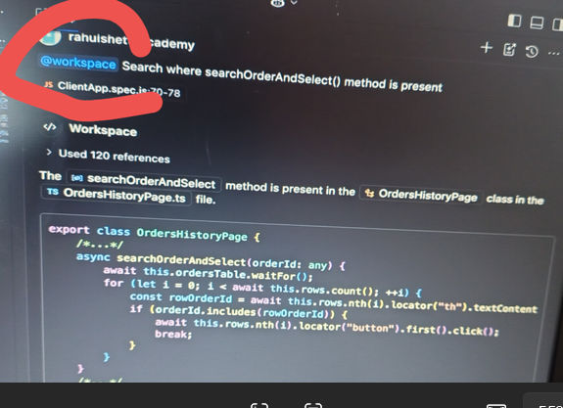

2.
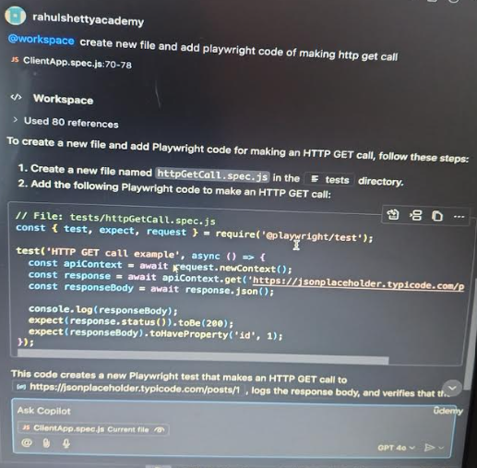

3.The testcase3 is failing due to syntax error,can you fix it?
-> it shows error and fix it

4. 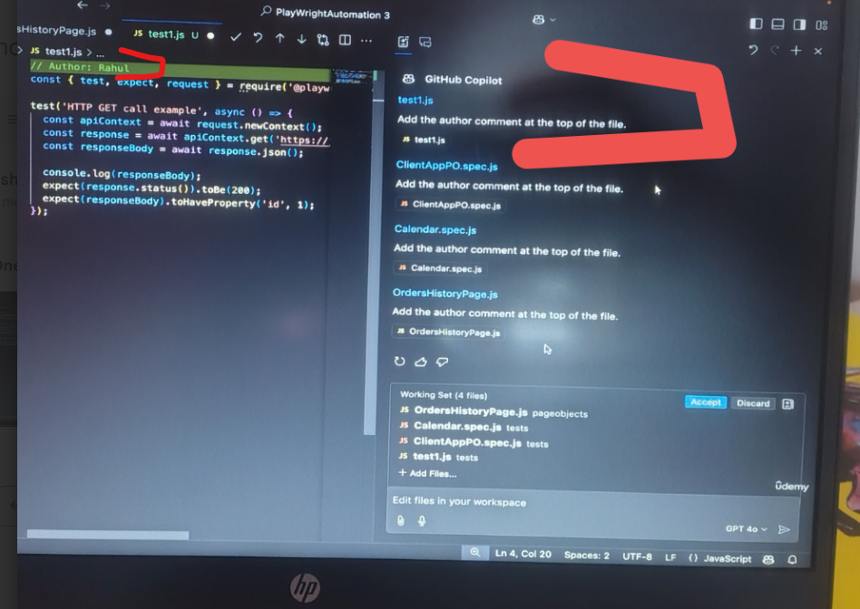

5.
Generate manual testcase for selected test case
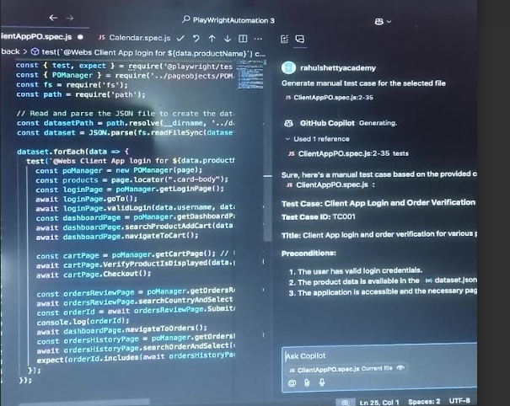

6. @terminal
